Chapter 14, Problem 2.

Using Fig. 14.69, design a problem to help other students to better understand how to determine transfer functions.
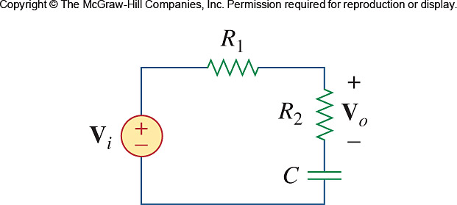

Figure 14.69
For Prob. 14.2.

